|  |  |
| --- | --- |
|  | **Web Designing Assignment**  **Module (CSS and CSS 3) -2** |

1. **What are the benefits of using CSS?**

**Ans:** CSS is defined as a method sheet language that provides web designers control over how an internet site communicates with web browsers including the formatting and display of their HTML documents.

**Benefits of CSS:**

* CSS plays an important role, by using CSS you simply got to specify a repeated style for element once & use it multiple times as because CSS will automatically apply the required styles.
* The main advantage of CSS is that style is applied consistently across variety of sites. One instruction can control several areas which is advantageous.
* Web designers needs to use few lines of programming for every page improving site speed.
* Cascading sheet not only simplifies website development, but also simplifies the maintenance as a change of one line of code affects the whole web site and maintenance time.
* It is less complex therefore the effort are significantly reduced.
* It helps to form spontaneous and consistent changes.
* CSS changes are device friendly. With people employing a batch of various range of smart devices to access websites over the web, there’s a requirement for responsive web design.
* It has the power for re-positioning. It helps us to determine the changes within the position of web elements who are there on the page.
* These bandwidth savings are substantial figures of insignificant tags that are indistinct from a mess of pages.
* Easy for the user to customize the online page
* It reduces the file transfer size.

1. **What are the disadvantages of CSS?**

**Ans: Disadvantages of CSS:**

* CSS, CSS 1 up to CSS3, result in creating of confusion among web browsers.

With CSS, what works with one browser might not always work with another. The web developers need to test for compatibility, running the program across multiple browsers.

* There exists a scarcity of security.
* After making the changes we need to confirm the compatibility if they appear. The similar change affects on all the browsers.
* The programming language world is complicated for non-developers and beginners. Different levels of CSS i.e. CSS, CSS 2, CSS 3 are often quite confusing.
* Browser compatibility (some styles sheets are supported and some are not).
* CSS works differently on different browsers. IE and Opera supports CSS as different logic.
* There might be cross-browser issues while using CSS.
* There are multiple levels which creates confusion for non-developers and beginners.

1. **What is the difference between CSS2 and CSS3?**

**Ans:** The main differences of CSS2 and CSS3 are as below:

|  |  |  |
| --- | --- | --- |
| **No.** | **CSS2** | **CSS3** |
| 1 | CSS splits up different sections of the code into modules | Both CSS and HTML were put into a single file, there was no concept of modules before. |
| 2 | There are new ways you can write CSS rules with a bunch of CSS selectors | There were no new ways of writing the CSS rules. |
| 3 | There is no backward compatibility with CSS2 | There is backward compatibility maintained with CSS 3 |
| 4 | With CSS2 only web safe fonts can be used | With CSS3 special fonts can be used Such as those in Google Fonts and Typecast |
| 5 | With CSS2 the concept of simple selectors were present | With CSS3 the selectors were called as a sequence of simple seletors.com |
| 6 | Using CSS2, for rounded borders. coding the CSS styles were complex | With CSS3, there is provision for automatically assigning rounded borders to objects21 |
| 7 | CSS 2, splitting text into multiple columns required complex coding because the standard was not equipped enough to break the text into columns so that it would fit into a box | CSS3 has the capability to split text into various columns so that each text block appears as a layout of the newspaper. |
| 8 | CSS 2 Doesn’t support the Border- Box property | CSS3 supports the Border-Box property |

1. **Name a few CSS style components.**

**Ans:**  There are many more CSS style components. From them some components are as below:

* Align-items
* Background (image, clip, colour etc...)
* Border
* Box- Shadow
* Clip-path
* Column-span
* Display
* Flex
* Font-family etc….

1. **What do you understand by CSS opacity?**

**Ans:** The opacity in CSS is the property of an element that describes the transparency of the element. It is the opposite of transparency & represents the degree to which the content will be hidden behind an element.

We can apply the opacity with different styling properties to the elements. A few of them are discussed below:

Image Opacity: The opacity property is used in the image to describe the transparency of the image. The value of opacity lies between 0.0 to 1.0 where a low value represents high transparency and a high value represents low transparency. The percentage of opacity is calculated as Opacity% = Opacity * 100.

1. **How can the background colour of an element be changed?**

**Ans:** We can set background color by selecting the element by its class name of id name and then apply the background-color property on it to set the background color.

**Syntax: background-color: color_name;**

1. **How can image repetition of the backup be controlled?**

**Ans:** This task can be achieved by using the background-repeat property that will help us to control the repetition of the image. The background-repeat property in CSS is used to repeat the background image both horizontally and vertically. It also decides whether the background image will be repeated or not.

1. **What is the use of the background-position property?**

**Ans:** The background-position property in CSS is mainly used to sets the initial position for the background image ie., it is used to set an image at a certain position. The position that is relative to the positioning layer, can be set by using the [background-origin](https://www.geeksforgeeks.org/css-background-origin-property/) property.

**Syntax:**

**background-position: value;**

**Note:**The [background-image](https://www.geeksforgeeks.org/css-background-image-property/) is placed default to the top-left corner of an element with a repetition on both horizontally & vertically.

1. **Which property controls the image scroll in the background?**

**Ans:** The [background-attachment](https://www.geeksforgeeks.org/css-background-attachment-property/) property in CSS is used to specify the kind of attachment of the background image with respect to its container. It can be set to scroll or make it remain fixed. It can be applied to all[HTML](https://www.geeksforgeeks.org/html/)elements.

**Syntax:**

**background-attachment: scroll|fixed|local|initial|inherit;**

1. **Why should background and color be used as separate properties?**

**Ans:** The major difference between CSS background vs background-color property is that the background property is shorthand of all background properties. On the other hand, the background-color property is the subset of the background property used to set the background color.

1. **How to center block elements using CSS1?**

**Ans:** There are two steps to center a block-level element –

**Step 1: Define the external width –**We need to define the external width. Block-level elements have the default width of 100% of the webpage, so for centering the block element, we need space around it. So, for generating the space, we are giving it a width.

**Step 2: Set the left-margin and the right-margin of the element to auto –**Since we produced a remaining space by providing external width so now, we need to align that space properly that’s why we should use margin property. Margin is a property that tells how to align a remaining space. So,for centering the element you must set left-margin to auto and right-margin to auto.

1. **How to maintain the CSS specifications?**

**Ans:** The CSS specifications are maintained by the [**World Wide Web Consortium**](http://www.w3.org/)**(W3C)**. Even though every browser supports CSS, there are many inconsistencies in the supported specification version. Some browsers even have their own implementation of the specification and have proprietary (vendor) prefixes.

**Maintenance Process:**

* **Community Involvement:** The Working Group welcomes public comments and participation in discussions through GitHub and mailing lists.
* **Testing and Feedback:** Implementations of new features are tested in browsers and feedback is incorporated.
* **Standardization:** Once stable, features are formally adopted by the W3C, becoming official parts of the specification.

1. **What are the ways to integrate CSS as a web page?**

**Ans:** There are three main ways to integrate CSS into a web page:

**1. Inline CSS:**

* This method involves adding the style attribute directly to an HTML element.
* Pros: Easy for small customizations, good for testing styles.
* Cons: Difficult to maintain for large websites, makes HTML cluttered, overrides external styles.
* **Example:**
* <p style="text-align: center; color: white; font-size: 20px; font-weight: 700; ">or login with</p>

**2. Internal CSS:**

* This method involves placing the CSS code within a <style> element inside the <head> section of your HTML document.
* Pros: Easier to maintain than inline styles, still linked to a specific HTML document.
* Cons: Not reusable across multiple pages, can bloat the HTML file if styles are extensive.
* **Example:**

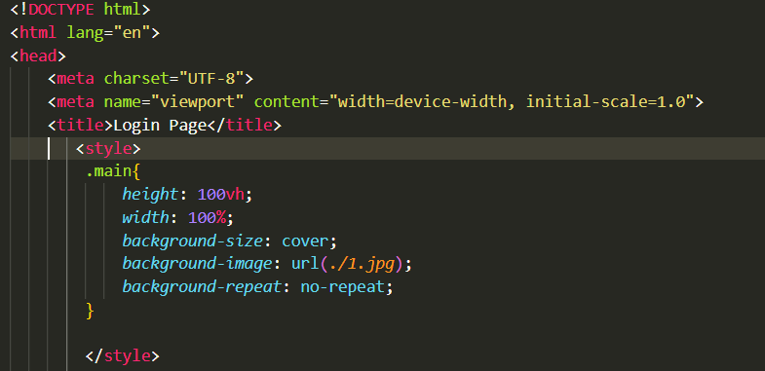

**3. External CSS:**

* This method involves creating a separate .css file containing all your styles and linking it to your HTML document using the <link> element in the <head> section.
* Pros: Most recommended method, promotes code reusability, keeps HTML clean, styles can be applied to multiple pages easily.
* Cons: Requires an extra file to manage.
* **Example:**

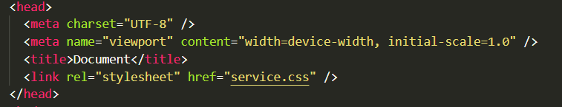

1. **What is embedded style sheets?**

**Ans:** Embedded stylesheets, also known as internal stylesheets, are a method of integrating CSS styles directly into your HTML document. They are defined within the <style> element placed in the <head> section of your HTML code.

**For example:**

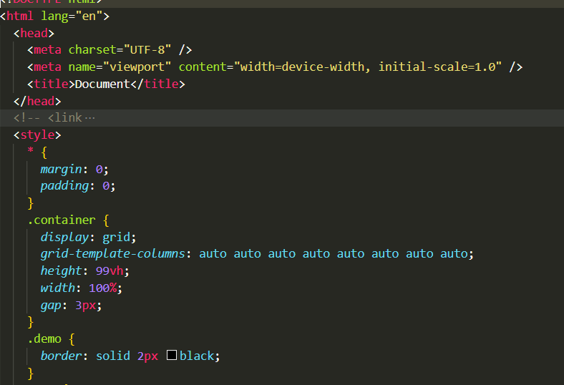

1. **What are the external style sheets?**

**Ans:** External CSS is used to style multiple HTML pages with a single style sheet. External CSS contains a separate CSS file with a .css extension. The CSS file contains style properties added on selectors (For example class, id, heading, … etc.)

**For example:**

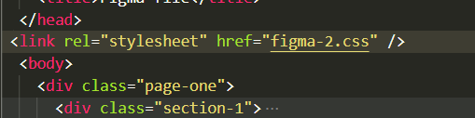 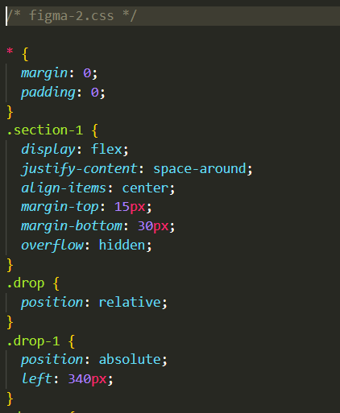

1. **What are the advantages and disadvantages of using external style sheets?**

**Ans: Advantages of External CSS:**

* Improved maintainability and code organization.
* Enhanced reusability across multiple HTML files.
* Efficient caching and faster page load times.

**Disadvantages of External CSS:**

* Pages may not render correctly until the external CSS is loaded.
* Uploading or linking to multiple CSS files may increase your site’s download time, affecting its overall performance.
* Large-scale projects may face versioning and caching challenges when using external CSS.

1. **What is the meaning of the CSS selector?**

**Ans:** A CSS selector is a pattern used to target specific HTML elements on a webpage. This allows you to apply styles (like font color, background, borders, etc.) to those elements individually, creating a well-structured and visually appealing website.

**We can divide in 5 types of CSS selector:**

* **Simple selectors**
* **Combinator selectors**
* **Pseudo-class selectors**
* **Pseudo-element selectors**
* **Attribute selectors**

1. **What are the media types allowed by CSS?**

**Ans:** CSS allows media types which are as below:

* **all:** Suitable for all devices.
* **aural:** Intended for speech synthesizers.
* **braille:** Intended for braille tactile feedback devices**.**
* **embossed:** Intended for paged braille printers.
* **handheld:** Intended for handheld devices (typically small screen, monochrome, limited bandwidth).
* **print:** Intended for paged, opaque material and for documents viewed on screen in print preview mode. Please consult the section on paged media.
* **projection:** Intended for projected presentations, for example projectors or print to transparencies. Please consult the section on paged media.
* **screen:** Intended primarily for color computer screens.
* **tty:** Intended for media using a fixed-pitch character grid, such as teletypes, terminals, or portable devices with limited display capabilities.
* **tv:** Intended for television-type devices.

1. **What is the rule set?**

**Ans:** A CSS ruleset is various affirmations to various pieces or elements of the document. The objective is to apply a bunch of properties for certain distinct qualities to a solitary, or a particular arrangement of components in the connected HTML page.

The diagram of CSS ruleset as below:

